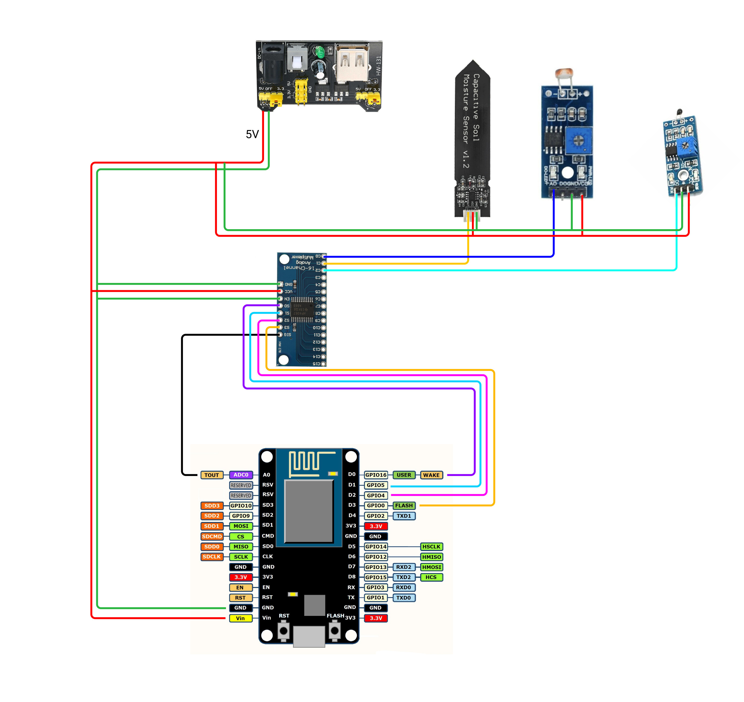

Hi,

I’m having problems with my sketch. I’m receiving the sensor numbers totally scrambled, for example when I shine light to the LDR, the numbers of the other sensors also change.

I’ve already checked the wires and everything seems to be correct.

On beginning I taught it was the timers. I put they on different gaps, but it isn’t working.

Maybe I do not fully understand how to code for Blynk to read the multiplexer correctly.

Some clue on whats happening?

Sorry my english.

Hardware:

NodeMCU (ESP8266)

Multiplexer 16ch CD74HC4067

Sensors:

LDR Module

Capacitive Soil Moisture Sensor v1.2

Thermistor Module 10K

#define BLYNK_PRINT Serial

#include <ESP8266WiFi.h>

#include <BlynkSimpleEsp8266.h>

#include <Wire.h>

#include <Thermistor.h>

#define S0 D0

#define S1 D1

#define S2 D2

#define S3 D3

#define SIG A0

int sensor0;

int sensor1;

int sensor2;

char auth[] = "xxx";

char ssid[] = "xxx";

char pass[] = "xxx";

BlynkTimer timer;

void setup()

{

  /* Debug console */

  Serial.begin(9600);

  Blynk.begin(auth, ssid, pass);

  Serial.println("");

  /* Timers */

  timer.setInterval(1000L, getSensor0); /* LDR */

  timer.setInterval(2500L, getSensor1); /* Soil */

  timer.setInterval(5000L, getSensor2); /* Thermistor */

  /* Multiplexer */

  pinMode(S0, OUTPUT);

  pinMode(S1, OUTPUT);

  pinMode(S2, OUTPUT);

  pinMode(S3, OUTPUT);

  pinMode(SIG, INPUT);

}

void getSensor0() {

  /* Channel 0 (C0 pin - binary output 0,0,0,0) */

  digitalWrite(S0, LOW); digitalWrite(S1, LOW); digitalWrite(S2, LOW); digitalWrite(S3, LOW);

  sensor0 = analogRead(SIG);

  Blynk.virtualWrite(V0, sensor0);

}

void getSensor1() {

  /* Channel 1 (C1 pin - binary output 1,0,0,0) */

  digitalWrite(S0, HIGH); digitalWrite(S1, LOW); digitalWrite(S2, LOW); digitalWrite(S3, LOW);

  sensor1 = analogRead(SIG);

  Blynk.virtualWrite(V1, sensor1);

}

void getSensor2() {

  /* Channel 2 (C2 pin - binary output 0,1,0,0) */

  digitalWrite(S0, LOW); digitalWrite(S1, HIGH); digitalWrite(S2, LOW); digitalWrite(S3, LOW);

  sensor2 = analogRead(SIG);

  Blynk.virtualWrite(V2, sensor2);

}

void loop()

{

  Blynk.run();

  timer.run();

}